**Bahria University, Lahore Campus**

Department of Computer Science

Lab Journal 07

**(Spring 2023)**

|  |  |  |
| --- | --- | --- |
| Course: | **Data Structures and Algorithm - Lab** | Date: _______________ |
| Course Code: | CSL-221 | Max Marks: 10 |
| Faculty’s Name: | Fatima Zulfiqar |  |

Name: AFFAN AHMAD_____ Enroll No: _03-134221-003__________________ Class: ______________

Objective(s):

Upon completion of this lab session, learners will be able to:

* Implement Recursive function and recursive calls
* Implement different problems using recursion

## Lab Tasks:

**Task 1**

Write a recursive function to calculate a factorial of a given number.

#include <iostream>

#include<string >

using namespace std;

int factorial(int val)

{

if (val <= 1)

{

return 1;

}

return val *factorial(val - 1);

}

**Task 2**

Write a recursive function to find nth number of the following series:

**0 1 1 2 3 5 8 13 21 …**

void series(int val)

{

static int n1=0, n2=1, n3;

if (val > 0)

{

n3 = n1 + n2;

n1 = n2;

n2 = n3;

series(val - 1);

}

cout << n3;

}

int main()

{

int a,b,n;

cin>>n;

//if (n == 1)

//{

// cout << "enter your number :"; cin >> a;

//// cout << "your " << a << " factorial :" << factorial(a) << endl;

//}

if (n == 2)

{

int num = 0;

series(6);

}

if (n == 3)

{

int i = 6;

string arr[6] = {"h,e,l,l,o,w"};

rev(arr, i);

}

system("pause");

return 0;

}

**Task 3**

Write a recursive function to reverse any given input string. Also display original and reversed string.

**Input:** Hello

**Output:** olleH

#include<iostream>

#include <string>

using namespace std;

void rev(string arr[],int i)

{i=i-1;

if (i > 0)

{

cout << arr[i]<<" ";

rev(arr , i );

}

}

int main ()

{

string arr[6]={"a","f","f","f","a","n"};

rev(arr,6);

return 0;

}

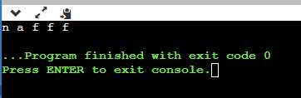

**Note: Don’t use any built-in functions.**

**Task 4**

Write a recursive function to check whether a given string is palindrome or not. A string will be palindrome if it is same even if it is read backwards. An examples of palindrome and non-palindrome sequences are given below:

**Input:** madam

Yes it is a palindrome

**Input:** Pulp

No! It is not a palindrome

**#include<iostream>**

**#include <string>**

**using namespace std;**

**int a=0,b=0;**

**void palin(string arr[],int i)**

**{**

**if (a==5)**

**{**

**i=i+1;**

**a=0;**

**}**

**if (arr[i]==arr[a])**

**{**

**b++;**

**}**

**else**

**{**

**a++;**

**}**

**if (i==5)**

**{**

**if (b>0)**

**{**

**cout <<"your word is palindrom "<< endl;**

**}**

**else**

**{**

**cout <<"your word is not palindrom "<< endl;**

**}**

**}**

**else**

**{**

**palin(arr , i );**

**}**

**}**

**int main ()**

**{**

**string arr[6]={"f","a","c","d","e","f"};**

**palin(arr,5);**

**return 0;**

**}**

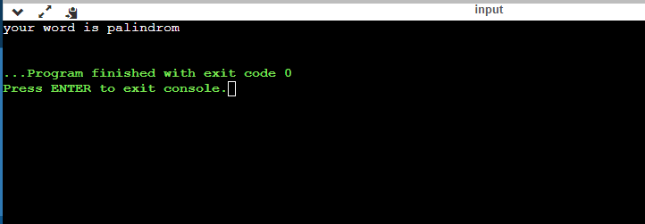

**Note:** The program should contain main-menu in such a way that all tasks are incorporated in a single program. The user can select either of the options until desires. Additionally the input to the node should be taken from the user.

**Lab Grading Sheet :**

|  |  |  |  |
| --- | --- | --- | --- |
| **Task** | **Max Marks** | **Obtained Marks** | **Comments(*if any*)** |
| 1. | 2.5 |  |  |
| 2. | 2.5 |  |  |
| 3 | 2.5 |  |  |
| 4 | 2.5 |  |  |
| **Total** | **10** |  | **Signature** |

**Note : Attempt all tasks and get them checked by your Lab Instructor. Also for each task, attach a screenshot of the output.**